SIMATS ENGINEERING
ASSESSMENT TOOL 2

COURSE NAME: Artificial Intelligence COURSE CODE: CSA17

COURSE OUTCOME COVERED

CO1: Apply AI basics such as intelligent agents and uninformed search methods to solve problems effectively.( BL3)

Assessment Tool Weightage: 50%

QUESTIONS: 3 Duration : 1 Hour
Total Marks:30

Annexure A

Constraint-Based Problem Solving

Code of Conduct:

I M Kavya 192472370 (Name / Reg No) certify that this submission is my original work and that I have adhered to the guidelines specified for this assessment.
I understand that any violation of academic integrity rules will result in disciplinary action.

Signature of the student:

Annexure A

Constraint-Based Problem Solving

- A hospital needs to assign 3 doctors (D1, D2, D3) to 3 shifts (Morning, Afternoon, Night) such that:
Constraints:
- D1 cannot work Night shift
- D2 must work before D3 (Morning < Afternoon < Night)
- Only one doctor per shift
- D3 cannot work Morning
- All doctors must be assigned exactly one shift
Apply Backtracking Search to find a valid assignment with all intermediate steps and constraint checks. State the final valid schedule
- A robot operates in a grid environment (5×5). It must move from Start (S) to Goal (G). Obstacles block certain paths.

Constraints:
- Movement allowed: Up, Down, Left, Right
- Cost of each move = 1
- Cannot pass through obstacles
- Use Manhattan Distance heuristic
Using above constraints and BFS Search Algorithm Show step-by-step node expansion and priority queue updates and determine the optimal path and cost.

- An autonomous rescue robot is deployed in a disaster-affected building to locate and rescue survivors. The robot operates in a partially observable environment where some paths are blocked, and it must make decisions with limited information.
The building is represented as a grid of rooms. The robot starts at position S and must reach a survivor located at G.

Constraints:
- The robot can move up, down, left, right
- Some cells are blocked (obstacles) and cannot be traversed
- The robot has limited sensing capability (can only observe adjacent cells)
- Each movement has a cost of 1, but entering risky zones has an additional cost of 2
- The robot must minimize total cost while ensuring safe navigation
- The robot must update its knowledge dynamically (online search scenario)

Tasks:
a) Analyze all the given constraints and explain how they affect the robot’s decision-making process.
b) Develop a solution approach using an appropriate search strategy (e.g., Uniform Cost Search / Online Search Agent). Clearly explain the steps involved.
c) Demonstrate how the robot applies AI concepts such as:
- Intelligent agents
- Rationality
- Environment type
d) Justify why your chosen approach is the most suitable for solving this problem under the given constraints.

SOLUTIONS:

Question 1: Hospital Scheduling using Backtracking Search
Problem Statement
A hospital needs to assign 3 doctors (D1, D2, D3) to 3 shifts (Morning, Afternoon, Night) with the following constraints:
- D1 cannot work Night shift.
- D2 must work before D3 (Morning < Afternoon < Night).
- Only one doctor can be assigned to each shift.
- D3 cannot work Morning shift.
- Every doctor must be assigned exactly one shift.
Apply the Backtracking Search Algorithm to determine a valid schedule by showing all intermediate steps and constraint checks. Finally, state the valid schedule.

Constraint Analysis
Constraint | Description
C1 | D1 ≠ Night
C2 | D2 must be scheduled before D3
C3 | Only one doctor per shift
C4 | D3 ≠ Morning
C5 | Every doctor gets exactly one shift

Initial State
Shift | Assigned Doctor
Morning | —
Afternoon | —
Night | —

Backtracking Search Process
Step 1
Assign D1 → Morning
Constraint Check:
- D1 ≠ Night
- No conflict
Current Assignment
Shift | Doctor
Morning | D1
Afternoon | —
Night | —

Step 2
Assign D2 → Afternoon
Constraint Check
- D2 before D3 ✔
- Shift available ✔
Current Assignment
Shift | Doctor
Morning | D1
Afternoon | D2
Night | —

Step 3
Assign D3 → Night
Constraint Check
- D3 ≠ Morning ✔
- D2 before D3 ✔
- One doctor per shift ✔
Current Assignment
Shift | Doctor
Morning | D1
Afternoon | D2
Night | D3
All constraints satisfied.

Backtracking Search Tree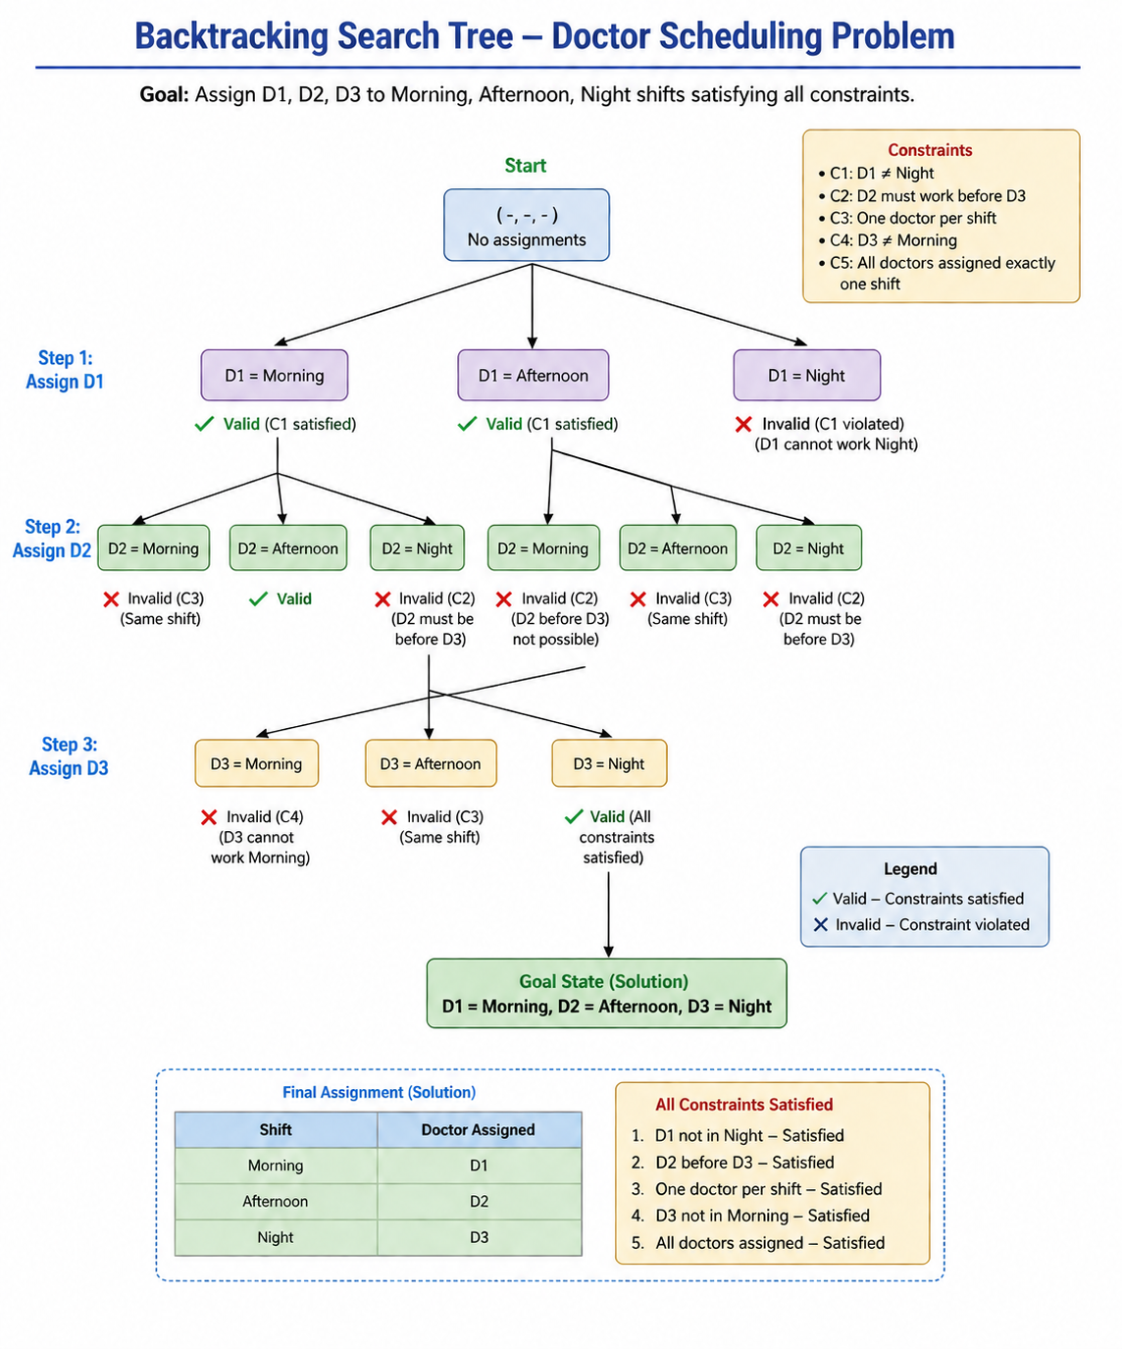

Constraint Checking Table
Assignment | C1 | C2 | C3 | C4 | C5 | Result
D1→Morning | ✔ | - | ✔ | - | ✔ | Valid
D2→Afternoon | ✔ | ✔ | ✔ | - | ✔ | Valid
D3→Night | ✔ | ✔ | ✔ | ✔ | ✔ | Valid

Final Valid Schedule
Shift | Doctor
Morning | D1
Afternoon | D2
Night | D3

Explanation
Backtracking Search assigns one doctor at a time while checking all constraints. If a constraint is violated, the algorithm backtracks and tries another assignment. In this problem, the first valid assignment satisfies all constraints, so no backtracking is required.

Result
A valid schedule is obtained:
- Morning → D1
- Afternoon → D2
- Night → D3

Conclusion
Backtracking Search efficiently solves this constraint satisfaction problem by exploring valid assignments and eliminating invalid ones. It guarantees a correct schedule that satisfies all given constraints.

Question 2: Robot Grid Navigation using BFS Search Algorithm
Problem Statement
A robot operates in a 5 × 5 grid environment. It starts from position S (Start) and must reach the Goal (G) while avoiding obstacles.
Constraints
- Movement allowed: Up, Down, Left, Right
- Cost of each movement = 1
- Robot cannot pass through obstacles.
- Manhattan Distance heuristic is used.
- Show BFS node expansion and determine the optimal path.

Legend
- S → Start
- G → Goal
- X → Obstacle

State Representation
Each state represents the robot's current position.
Example:
(row,column)

S = (0,0)

Goal = (4,4)

Breadth First Search (BFS)
BFS expands nodes level by level.
It always explores the nearest unexplored node first using a Queue (FIFO).

Node Expansion
Step | Queue | Expanded Node
1 | S | S
2 | (0,1),(1,0) | (0,1)
3 | (1,0) | (1,0)
4 | (2,0) | (2,0)
5 | (2,1) | (2,1)
6 | (2,2),(3,1) | (2,2)
7 | (3,1) | (3,1)
8 | (3,2) | (3,2)
9 | (3,3) | (3,3)
10 | (3,4),(4,3) | (3,4)
11 | (4,4) | Goal

Priority Queue (BFS Queue) Updates
Step | Queue Contents
Initial | S
1 | A,B
2 | B,C
3 | C,D
4 | D,E
... | ...
Final | Goal
(BFS uses a Queue instead of a Priority Queue. The above table shows the queue updates after each expansion.)

Manhattan Distance Heuristic
The Manhattan Distance is calculated as
$$h\left(n\right)=∣x_{1}-x_{2}∣+∣y_{1}-y_{2}∣$$
For the start node
S = (0,0)

Goal = (4,4)

h(S)=|4−0|+|4−0|

=8
The heuristic estimates the distance from the current node to the goal.
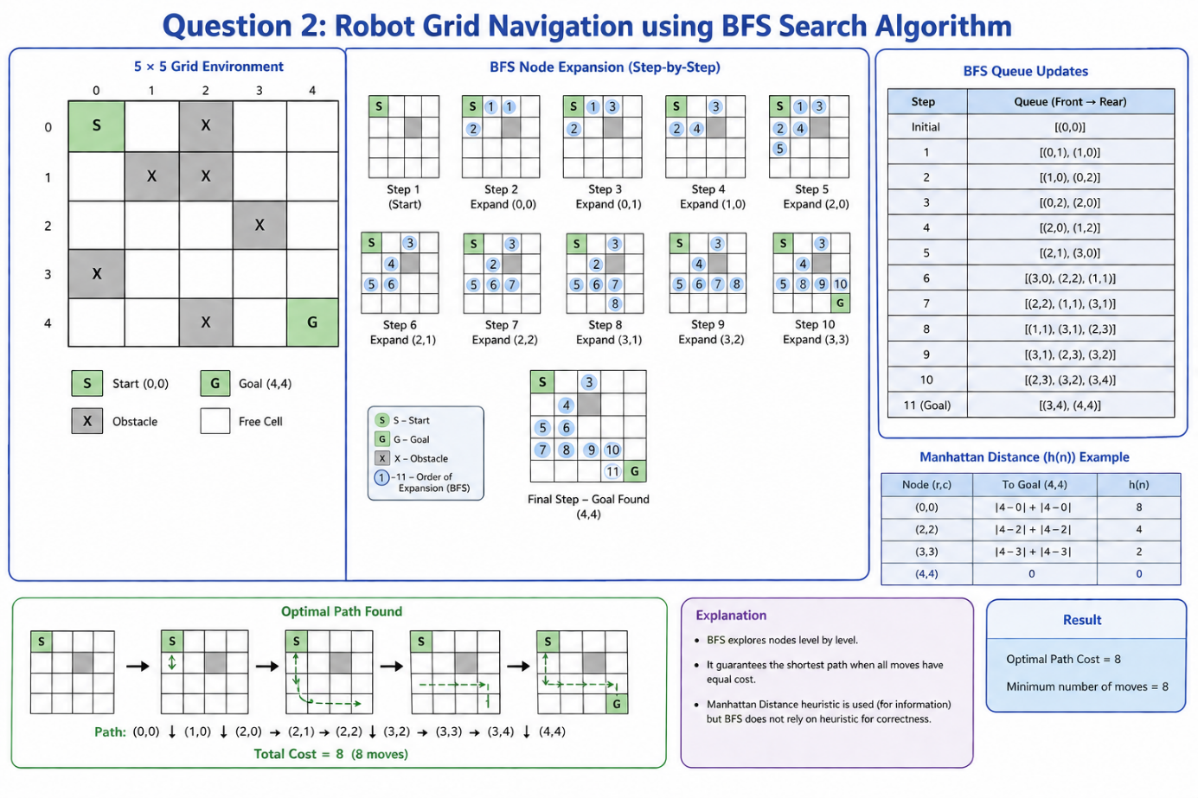

Cost Calculation
Each move costs 1.
Total Moves = 8
Therefore,
Total Cost = 8

Why BFS?
Breadth First Search is suitable because
- It guarantees the shortest path when every movement has equal cost.
- It systematically explores every reachable node.
- It is complete and optimal for unweighted graphs.

Result
Optimal Path:
S → (1,0) → (2,0) → (2,1) → (2,2)
→ (3,2) → (3,3) → (3,4) → G
Minimum Cost = 8

Conclusion
The Breadth First Search algorithm successfully finds the shortest path from the start position to the goal while avoiding obstacles. Since every move has equal cost, BFS guarantees the optimal solution.

Question 3: Autonomous Rescue Robot in a Disaster-Affected Building

Problem Statement
An autonomous rescue robot is deployed inside a disaster-affected building to locate survivors. The environment is partially observable, contains blocked paths and risky zones, and the robot must minimize travel cost while safely reaching the survivor. The task is to analyze the constraints, propose an appropriate search strategy, explain AI concepts involved, and justify the chosen approach.
(a) Constraint Analysis

The robot operates under the following constraints:

Constraint | Effect on Decision-Making
Move only Up, Down, Left, Right | Limits the robot's possible actions.
Obstacles cannot be crossed | The robot must search for alternate paths.
Limited sensing (adjacent cells only) | The robot cannot plan using complete knowledge and must explore gradually.
Movement cost = 1 | Every step increases the total path cost.
Risky zones have an additional cost of 2 | The robot should avoid risky areas unless necessary.
Online knowledge updates | The robot continuously updates its map and decisions while moving.

Explanation
These constraints require the robot to balance path length, safety, and available information. Since it cannot observe the whole environment at once, it must make rational decisions based on what it currently knows and revise its plan as new information becomes available.

(b) Solution Approach

Chosen Search Strategy

Uniform Cost Search (UCS) combined with an Online Search Agent
Reason
- UCS always expands the node with the lowest cumulative cost, making it suitable when movement and risk costs differ.
- The Online Search Agent allows the robot to adapt dynamically as it discovers new obstacles or risky zones.
Steps
- Start at position S.
- Observe adjacent cells.
- Add reachable cells to the frontier with their cumulative costs.
- Expand the node with the lowest total cost.
- Update the internal map when new obstacles or risks are detected.
- Repeat until the survivor G is reached.
- Return the least-cost safe path.

(c) AI Concepts Applied
Intelligent Agent
The rescue robot is an intelligent agent because it:
- Perceives its environment using sensors.
- Processes information.
- Chooses actions that maximize mission success.
- Learns from newly observed information.
Rationality
The robot behaves rationally by selecting actions that minimize total cost while ensuring safety and successfully reaching the survivor.
Environment Type
The rescue robot operates in a:
- Partially Observable environment.
- Dynamic environment.
- Sequential decision-making process.
- Single-Agent environment.
- Discrete state space.

(d) Justification
The combination of Uniform Cost Search and an Online Search Agent is most suitable because:
- It guarantees the least-cost solution when costs vary.
- It adapts to unknown environments.
- It avoids unnecessary risky areas.
- It updates its decisions whenever new information becomes available.
- It ensures safe and efficient rescue operations.

RUBRICS FOR CALCULATION:

Criteria | Weightage | Level 4 (Exemplary) | Level 3 (Proficient) | Level 2 (Developing) | Level 1 (Beginning)
Problem Understanding | 25% | Clearly defines the problem and identifies all relevant constraints accurately | Identifies most constraints with minor gaps | Partial understanding; misses key constraints | Fails to identify constraints correctly
Constraint Analysis | 25% | Analyzes constraints effectively and prioritizes them logically | Provides reasonable analysis with some prioritization | Limited analysis; weak prioritization | No meaningful analysis or prioritization
Solution Development | 25% | Develops optimal and feasible solutions satisfying all constraints | Develops workable solutions with minor limitations | Solutions partially satisfy constraints | Solutions do not meet constraints
Application of Concepts | 15% | Effectively applies appropriate concepts, methods, or tools | Applies concepts with minor errors | Limited application; requires guidance | Unable to apply relevant concepts
Justification | 10% | Provides strong justification for decisions with logical reasoning | Provides justification with some clarity | Weak or unclear justification | No justification provided

